**1.1 Print and Comments**

* **Description:** Make the computer output text “Hello World”

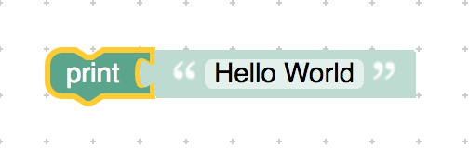

<xml xmlns="http://www.w3.org/1999/xhtml">

 <variables></variables>

 <block type="text_print" id="m{[@,lFs%z0YKIOxj@z-" x="-112" y="-87">

    <value name="TEXT">

     <shadow type="text" id="AsESNowomU.O?]|YfrA.">

       <field name="TEXT">Hello World</field>

     </shadow>

    </value>

 </block>

</xml>